2-1-2020

Luis Gómez

Javier Navarro Juan

Gianluca Paniccuchi

Mario San Emeterio de la Parte

System of Systems Modelling

Cyberphysical Systems Modelling

**Content table**

Figures table 2

1. Introduction 3

2. Scope of the System 4

3. Current solutions 6

3.1 DGT 6

3.2 Emergencies services 6

3.3 Other examples 8

3.4 Conclusions 9

4. Stakeholders 10

4.1 Customers 11

4.2 Governments 11

4.3 Communities 11

4.4 Emergency centers 11

4.5 Car companies 12

4.6 Suppliers 12

4.7 Investors 12

4.8 Employees 12

5. Current Systems in the market and in Spain government 12

6. Analysis 14

6.1 Functional requirements 14

6.2 Non-functional requirements 15

6.3 Use cases 15

7. Design 17

7.1 Systems chosen and compose the SoS solution 17

7.2 Architecture patterns 19

7.3 Architecture diagram 21

Bibliography 22

# Figures table

Figure 1: Communication chain of eCall. Source: HeERO. 7

Figure 2: Example of an IoV system applied to the traffic accidents. 8

Figure 3: Stakeholders. 10

Figure 4: Emergency Center. 11

Figure 5: Matrix.co.za. 13

Figure 6: Police drones. 13

Figure 7:Traffic Accident Mitigation SoS 16

Figure 8: Papyrus design. 17

Figure 9: e-Call system. 18

Figure 10: Publish/subscribe pattern. 20

Figure 11: Architecture Diagram. 21

# Introduction

The objective of this document is to analyze the current status of the traffic accidents and try to design a System of Systems ready to mitigate the traffic accidents in the roads.

The main mission in this project is to design a solution that can reduce the road fatalities, acting in the shorter time as possible.

This could be possible distributing the emergencies forces in a smart way, taking account the severity of the accidents and the available emergencies units near of the accident.

One of the main components in this solution is the use of drones. Drones can take pictures of the accident scenario for better understanding of the accident, that allow the rest of the system to know the best emergency response for the accident mitigation.

The document is structured in different sections:

* Scope of the system for delimiting the document
* Current solutions for showing the developed systems that already exists
* Stakeholders for describe the different people that are involved in the project
* Analysis though the functional a non-functional requirement.
* Design of the systems taking account the different requirements, stakeholders and the scope of the system.

# Scope of the System

In relation to the scope of the project, along these chapter it is going to be describe the different applications and the requirements predefined for the development and implementation of the system.

On the one hand, the study of the most innovative, powerful and actual projects developed and also, the future projects and technologies that are going to be develop for the future will be covered on this document. With this, it is intended to know the current framework in which the system exists, as well as the needs and interests of the different organizations and the possibilities offered by the current technology for the development of the project.

On the other hand, this document is focused in the analysis of the different requirements in the modelling of the system of systems. To highlight the different systems involved, it is needed to attend to some entities, like the emergency operator’s system, whose are in charge of the emergency calls from the different injures or people that need some kind of assistance. They are the maximum responsible of understanding the caller´s situation as well as understanding the needs. For instance, in the community of Madrid, there are around 240 professionals and another 200 from other emergency services, behind the service 1-1-2 to attend all the emergency calls from the community [1]. This service is designed according to a criterion that allows all emergency agencies to be operatively integrated, through the precise agreements to define the procedures that determine when each service must be activated.

As for the organizations involved in the process of attention to victims, they must have accurate information to deal with the incident, which includes geolocation, provided with some minimum degree of precision, the needs to be covered and a description of the current situation, as well as the road or location where the accident happened, to know its accessibility. It should be mentioned that the efforts destined to each operation (unities of ambulances, fire-fighters and policeman), must be the necessary ones, in order to cover the high demand and optimize the resources and attention time.

The project aims to de-involve the human factor or, in other words, the accident victims from the process. In this way, the injured or possible witnesses will not need to make a call or notice to the emergency services. This is a breakthrough, since the participation of one or more individuals who may have symptoms of anxiety, shock or nervousness is eliminated from the process, because, in some cases, they do not know how to identify the accident or the exact location of the events. On the other hand, it is intended to delegate these functions to the vehicle itself, which will be the one to notify emergency services in the first instance, as well to a UAV system that will allow a determination and analysis of the needs and situation of the accident with high accuracy and speed. For the implementation of the UAV swarm, a node design is carried out that transmits the information of the different sensors.

The development of a platform for the management of the emergency service will be essential. In this way, the different situations can also be controlled from the operations center and even derive the history of data to different relational and non-relational databases, in order to improve the behaviour of the system according to the response granted to previous accidents.

It is very important to highlight the importance of the car industry for the development. It is because, one of the key elements in the project is a black box that will be integrate in the cars, in order to be able to send alerts when some kind of problem is detected or an accident occurs. The system alert message can be controlled according to the type of incident detected, so that the maximum information is available as quickly as possible, without putting those affected at risk. Therefore, a study of the different stakeholders will be carried out in chapter 4.

There will be a first design of a robust and scalable project in order to do all the necessary improvements before the implementation in the maximum number of cars as possible. This step is totally necessary to develop a first scenario where to study the response of the system and adjust it to an optimal operation.

The next step is the scaling of the system and the agreement with the different entities that are part of the system of systems to be able to implement the platform as soon as possible and increase the number of vehicles that have the system gradually.

This development of the project assumed that there will be collaboration between the different entities that will be part of the system. So, it is very important the communication and standardization of the messages and the way to transmit the alert to the platform to be use by the emergency services in an easy and friendly way. This assumption of collaboration is based on the fact that nowadays there are some projects that have been implemented under the work developed by these entities together, like is described in the next chapter.

The justification for the development of the system is to help in the coordination between entities and to mitigate the risks in the traffic accidents. This will suppose a big improve in the design of cars that will be connected to the emergency services and will offer a more closed relation between these organizations in order to create a much more safety way to travel.

The project will be implemented in Madrid, before being developed in other regions or countries, under the financing of the European Union, as it is a first instance of a research project, to increase the efficiency and standardization of the platform. In this way a high level of compatibility will be achieved between the various brands and vehicle manufacturers, to include the black box in the design of the cars, and, for the development of security in the transmission of data packets, as well as easy understanding in the way of use the platform. For this, the different communication protocols between organizations and the various current forms of action will be studied. In addition, the development will be based on the study of the current solutions in the market, in order to distinguish the success factors and the possible problems raised in the implementation (autonomy of UAVs, speed and consistency in the transmission of data etc.).

# Current solutions

In this chapter, the most innovative solutions provided by the organizations and entities involved in the development of the technology will be analysed. This study will be taken as a starting point for the modelling of the system of systems, the taking of requirements and the design of the architecture.

It should be noted that currently we are investigating the implementation of systems that use the IoV (Internet of Vehicles), to improve safety and immediate attention to possible accident victims, caused by all kinds of environmental, engineering problems or simply of the human factor.

## 3.1 DGT

On the one side, the “General Directorate of Traffic” (Spain), has just deployed a system of drones intended for the surveillance of drivers and with the ability to fine in case of the sighting of an infraction. Such infractions such as throwing a cigarette butt or skipping a stop can be controlled directly by these drones. However, at the moment its application is not contemplated for any type of roadside assistance or the sighting and characterization of accidents [2].

As for the inclusion of new technologies by the DGT, they are mainly applied to systems of warning of involuntary lane change or automatic or autonomous braking [3]. However, it is desired to move the development of mobile applications, intelligent systems or Big Data to the field of road safety and mobility. The ultimate goal is to change the way we use roads and vehicles; thus, expand the capacity and efficiency of roads or even choose the way of driving, such as going or even traveling without driving, that is, autonomously by the vehicle. We can find more details in [4].

The most used methods are focused on the statistical study for the prevention of accidents, the determination of the main causes and even the reconstruction of the same to be able to analyse different components of relevance in the result of the accident itself. One of the examples is the analytical reconstruction of traffic accidents or their reconstruction using computer methods for 3-dimensional modelling.

In addition, there are several international databases with the characteristics of accidents, such as the BD “GIDAS”, “CCIS” or that of “Volkswagen” or INRETS-CEESAR. Therefore, the improvement or provision of new equipment or systems for accident assistance or the update of the methods of warning and detection of them by this body is not assessed [5].

## 3.2 Emergencies services

Regarding the implementation of new technologies in emergency services, we can find, as one of the main objectives, the implementation of the “eCall” system in Center 112 of the community of Madrid. This system is embarked on vehicles and in case of emergency will make a call to the emergency number 112; The call will be made automatically by activating sensors or manually. This objective has been met in September 2018 [6].

For further development of the claims of the European eCall project, it consists in the implementation of a device, which, incorporated into the vehicles, notifies the authorities and emergency bodies, in a period of 15 to 30 seconds. However, in Spain, this time will be about 30 seconds considering that the call will have to go through the DGT first. Even so, it is intended to reach a figure close to 5% reduction in the number of victims and 6% in terms of the severity of the injured.

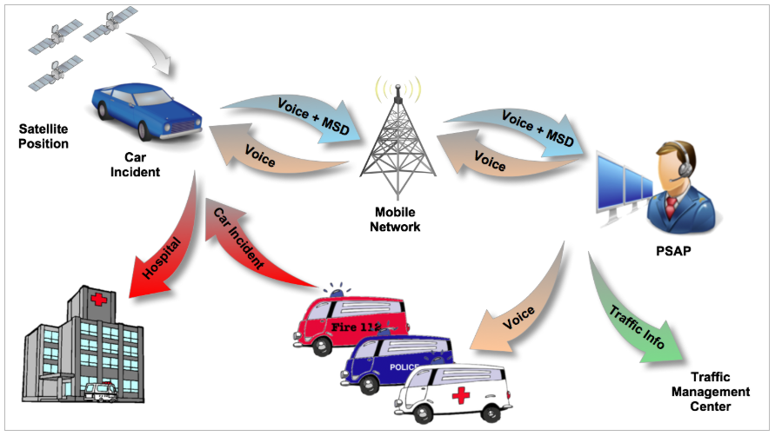

Figure 1: Communication chain of eCall. Source: HeERO.

In addition, in June 2017, the renewal of the telephone exchange and the management of emergency calls on IP technology took place [7].

As for applications for mobile devices, free applications such as “APP112 SOS DEIAK” or others such as assistance by “WhatsApp” or “Alpify-Safe365” are already available. These applications can be used to facilitate the work of rescue teams in situations of risk or loss of people, thanks to geolocation.

It is worth mentioning the current benefits of the emergency call service 112, since it allows activating all the agencies simultaneously improving the response time, in addition, it allows the immediate location of the caller and is designed with scalability criteria that allow incorporating new technologies such as the modelling object of this project.

## 3.3 Other examples

We can find different publications that refer to the inclusion of new technologies for the assistance and detection, in the first instance, of traffic accidents. As is the case in the document on the IEEE 8th International Conference on Consumer Electronics in Berlin, Germany in 2018. In that paper it is proposed a Deep-learning based Internet of Vehicles system, which consist of an in-vehicle infotainment telematics platform with collisions detection sensor and a cloud based deep learning training server and a web-based service platform. The goal of this system is shown as an experimental result, where the accuracy of traffic accident collisions detection can be achieved up to 96%, as well as improve the average response time to send the emergency announcement of approximately 7 seconds. The following picture shows an example of the IoV system applied to the traffic accidents immediately collisions detection, analysis, and alarms:

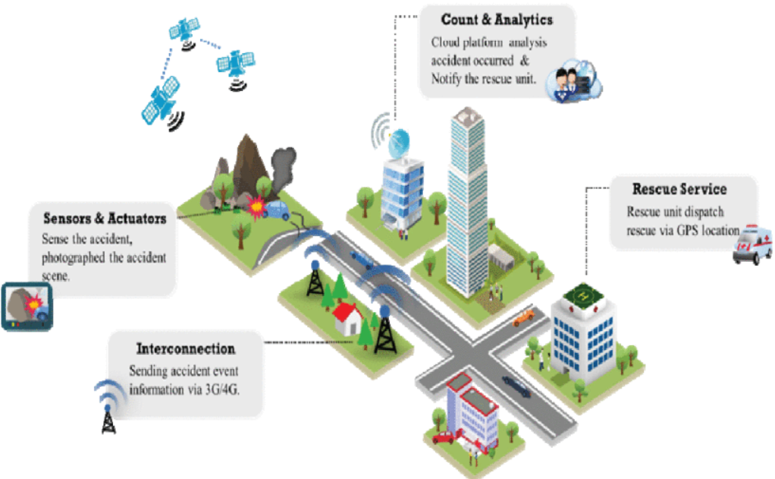

Figure 2: Example of an IoV system applied to the traffic accidents.

The biggest problem to solve lies in the figures. The global status report on road safety 2015 of the World Health Organization (WHO) [8], pointed out that about 1.25 million people die each year due to traffic accidents in the world, indirectly caused from 20 to 50 million people to have nonlethal injuries. Also, about 90 % of road traffic accidents occurred in low- and middle-income countries where the low level of emergency rescue energy and medical standards are the causes of a bigger mortality rate of accidents [9].

## 3.4 Conclusions

Regarding the conclusions obtained once the study of the current situation on the implementation of different technologies for the assistance and detection of accidents, or the improvement in communication between emergency entities (such as police, fire fighters or health care) has been carried out. In a first instance, certain solutions have been found with similar characteristics to those proposed in the system modelling of this document. However, none of them has a drone system to facilitate such communications and the characterization of the damage and needs that the accident presents. So, the project can be framed in the innovation or improvement of some of the services and projects proposed in recent years, but which, incorporates new features, as well as a much more efficient use of the resources we have available in terms of emergency care and services.

It is worth mentioning that the projects developed so far, are focused on meeting the needs of several entities and organizations at the same time, so a close collaboration between them is required. These examples help to understand the current needs of these organizations and even the most relevant aspects to be covered by the project.

The fact of finding several examples with similar characteristics demonstrates the interest of the different organisms involved, in the development of this type of technologies. In this way, it is possible to improve and update emergency services, which constitute one of the factors of greatest interest to the citizen.

Therefore, through the development of this new technology, its scalability and standardization are intended. Since, currently, there are different collaborating entities such as car brands or the emergency agencies themselves or even the police, as has been observed in the solutions proposed in the previous subsections.

# Stakeholders

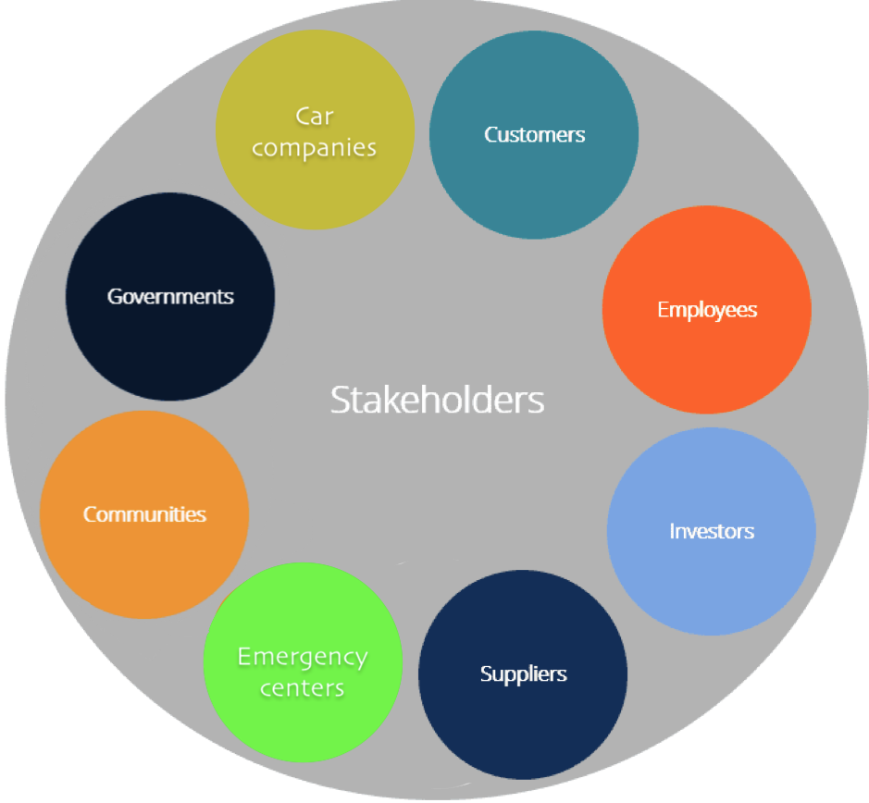

Figure 3: Stakeholders.

A stakeholder is for definition an entity who has legitimate interest in a given situation, action, society or project. In this particular case we’re going to see a list of few different kind of subjects and entities which are going to be affected by the presence and the functioning of this system.

Being this, a system whose target is eventually every single vehicle on the road, requiring the integration between existing emergency response mechanism and behaving as a public service the net of stakeholders becomes quite wide and complex and tricky to analyze.

Let’s first distinguish between the concept of Internal and External stakeholders:

· Internal: stakeholders who participate in the co-ordination, funding, resourcing and publication of the strategy from a local health and well-being partnership;

· External: stakeholders who are engaged in contributing their views and experiences in addressing the issues that are important to them as patients, service users, carers and members of the local community.[1]

In fact, even if we’re not necessarily dealing with a private company, since we’re talking about a public service in which the direct owner might be the government, we can still distinguish between these 2 cases.

## 4.1 Customers

In this model, customers are considered as the main external stakeholders of this system since they are in number the major part who is going to be affected positively or negatively by how well the system is going to perform. They can get the possibility of having an autonomous system (provided by the black boxes) that automatically detects a collision and send the localization of the event to the emergency system, guaranteeing the intervention of the first responders even in case they are not directly able to notify the accident or provide the location of the emergency situation.

## 4.2 Governments

Government is the main internal stakeholder. This whole system is going to be used by a large number of people and it needs to integrate with the existing emergency and rescue system, which require a high level of responsibility and permissions, not to talk about the entire law and privacy issues. The government would play the most significant role in terms of leading and handling the system and its interest stays in how can be improved the emergency system in terms of security fastness and the eventual cut in the costs of sending emergency units that are not required for a specific case.

## 4.3 Communities

Each community would handle the drones distribution based on their specific policy on managing the emergency units. Like the government they are internal stakeholders of this system and they need to organize and regulate it on their specific needs.

## 4.4 Emergency centers

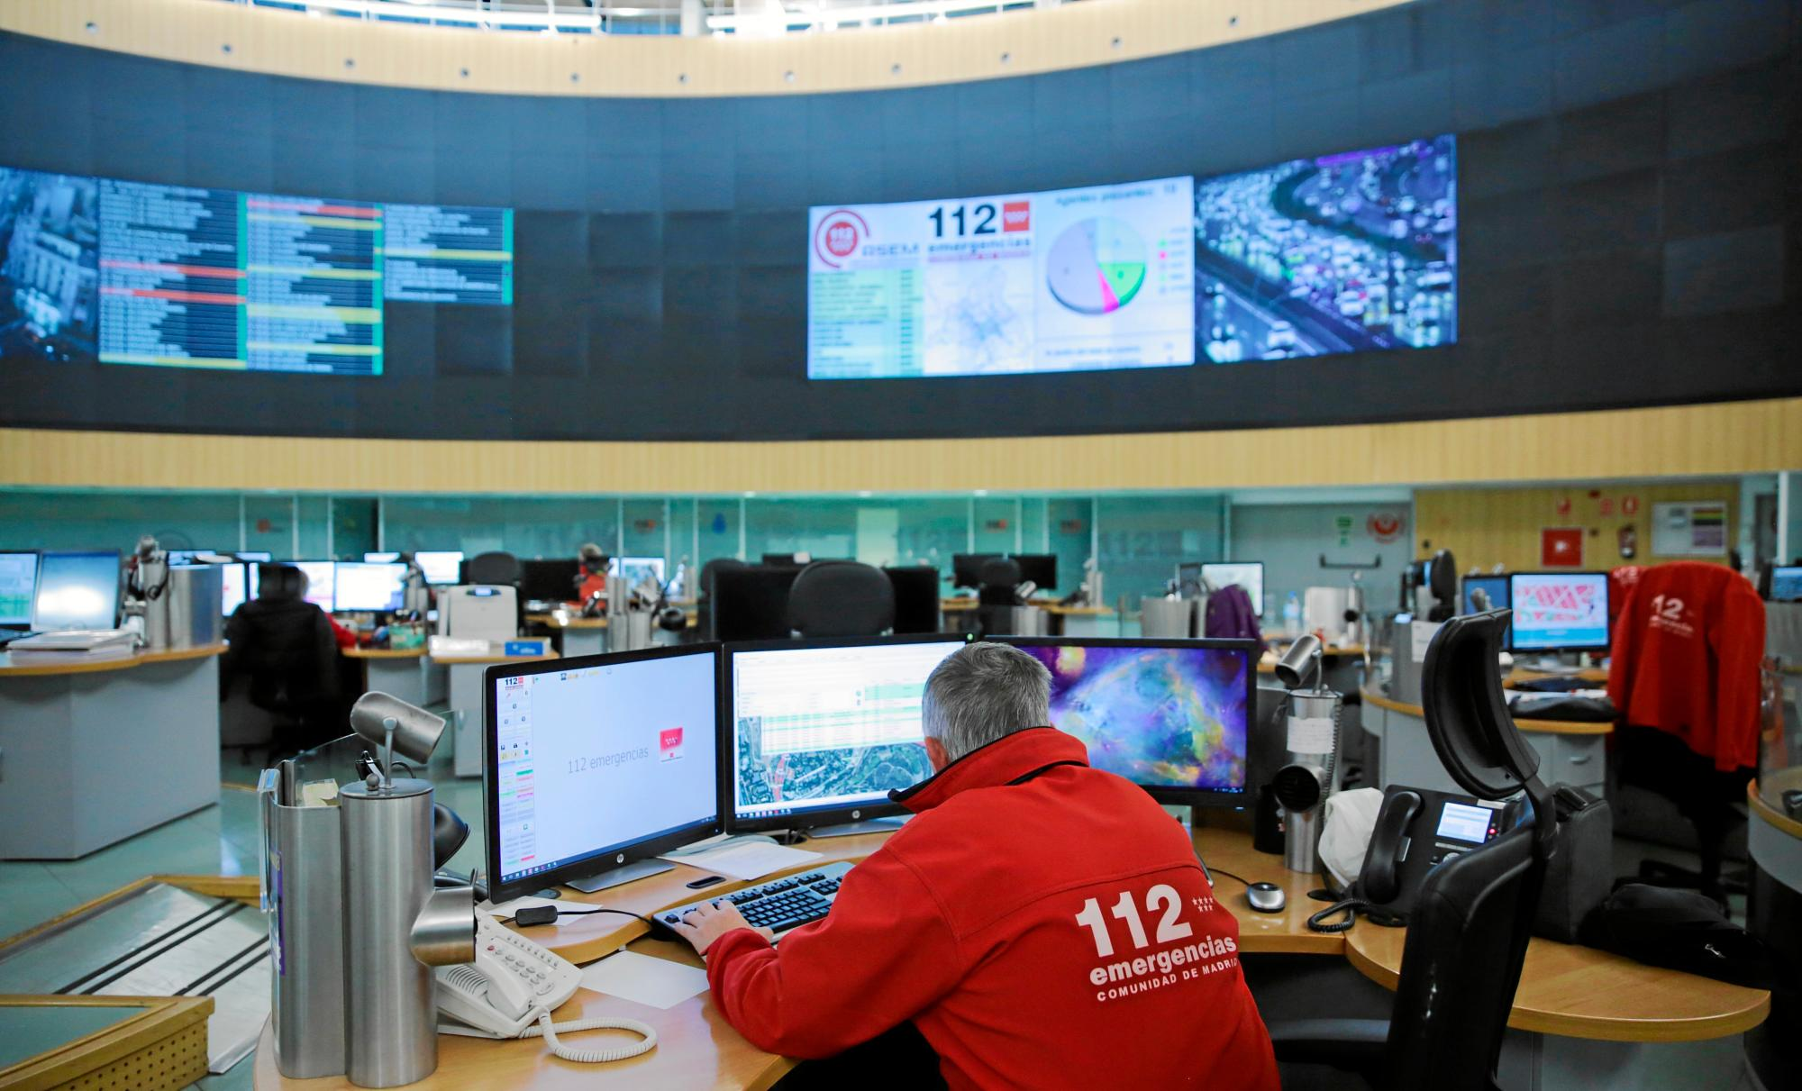At the moment the emergencies calls in most of the countries are received, processed and handled by centralized emergencies centers that most of the time respond to a unique phone contact, like the 112, where specialized and trained operators assists the customer trying to provide the best support and understand the emergency situation in order to send the most appropriate rescue unit to the accident location. These emergencies centers would be directly affected by the implementation of such a system, that would provide them another point of view to handle the emergency situation and decide whether or not to send an emergency unit rather than another.

Figure 4: Emergency Center.

## 4.5 Car companies

Car makers would be indirectly affected by the implementation of this system that requiring the installation of black boxes on the vehicles could be cut out from selling in an area or in a country where the adoption of this system could eventually be mandatory, making illegal to sell any car that doesn’t respect the legal standards.

## 4.6 Suppliers

The implementation of such a huge system on a national scale would generate a lot of need in technological supplies, starting from the drones, to the hardware and software systems to handle them, so another external stakeholder of this systems would become the suppliers of all of the required materials, which would open a new window of market, and economical interests.

## 4.7 Investors

The government would definitely be one of the main investors, but part of the costs and the benefits of this system would be eventually given to private investors that believe in this project, funding it and expecting to generate gain from it.

## 4.8 Employees

Finally, whenever a new service is started and implemented there’s the need of technicians taking care of all the set up and maintenance part, and as part of this project they are also stakeholders because their salaries are depending by the installation and the maintenance of the drones net.

# Current Systems in the market and in Spain government

There are already present in the market some car crash sensor, capable of detecting an accident and furnish assistance to the driver by automatically calling a call center and sharing the gps coordinates. I took as an example of these systems a service provided by an american company called Matrix, which is promoting 3 devices with different subscription plans, offering to its customers their service. Anyway this could be similar to the black box system used by the proposed solution, but it’s missing the whole fast in site check provided in our case by the drone, especially if the driver is not able to respond in case some really serious accident has occurred.

Also, this system lacks of the whole image recording feature, which can be useful in case of some legal issues occurs.

Figure 5: Matrix.co.za.

<https://www.matrix.co.za/crash-alert>

This second model instead is an example of how the drones are used in car crashes.

This company has created a system of drones that are used by Police agents to take 3D model after car crashes occurs. The company claims that in some situations is necessary to take some measurements right in the moment and in the place of the accident, operation that can take up to some hours, blocking the entire traffic flow and creating a real messy situation, that could be solved simply by taking air measurement with a centimetre precision system, able to create a 3d model of the crash scene to let the traffic be restored in few minutes.

<https://www.analistgroup.com/it/soluzioni-innovative-drone/misure-forensi/rilievo-incidenti-stradali>

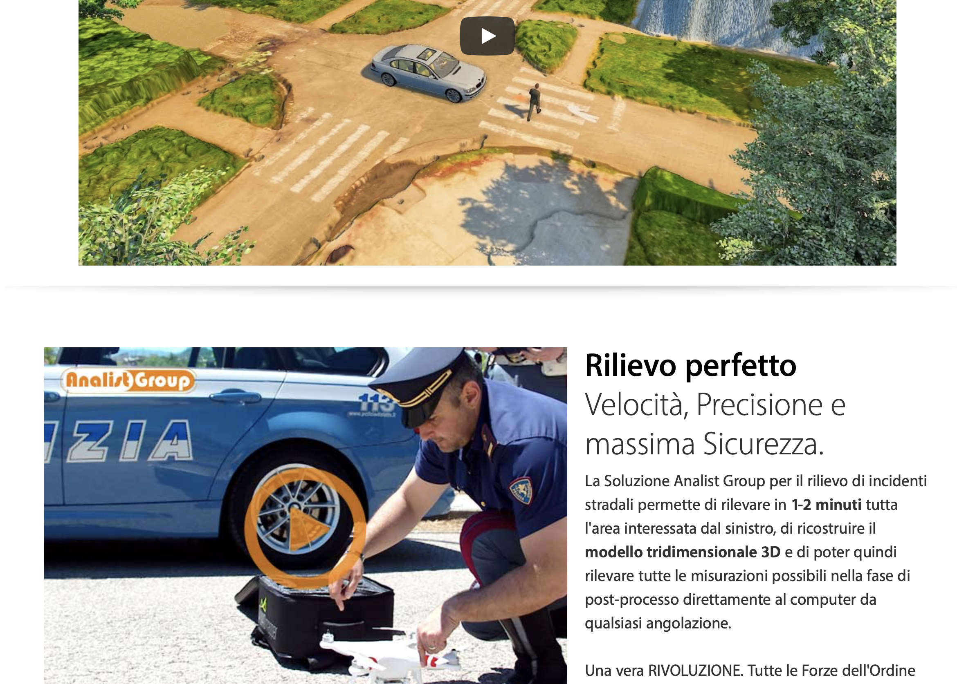

Figure 6: Police drones.

# Analysis

Following the Stakeholders necessities in the system of systems, it is necessary to define the requirements of the system in order to design a solution able to satisfy all the stakeholders.

This analysis is structured in the following way:

* The functional requirements are defined with the necessities of the previous involved stakeholders. All the functional requirements must contain the ‘Five Ws’ (Who, What, When, Where and Why).
* The non-functional requirements are all the QA (Quality Attributes) needed for build a complete solution.
* And the Use cases are the diagrams of functional requirements that show the composition of the list of actions and events steps defining the interactions between roles.

## 6.1 Functional requirements

* + 1. Customers
* FR1: As Customer I want to be attended by the emergencies system when my car interprets and accident in my current location for assure my life integrity.
* FR2: As Customer I want to have the road attended by the emergencies system when other cars have an accident in the accident location for avoid road blocks and prevent accidents.
  + 1. Governments
* FR3: As Government I want know the status of the road along the time when I want in data plot graphs for produce knowledge and develop politics for prevent car accidents.
  + 1. Communities

(Does not apply)

* + 1. Emergencies
* FR4: As Emergency operator I want to receive all the data of the car accident as possible for checking it and build an inform in order to compose the emergencies force request.
* FR5: As Emergency force I want to know all the possible information of the crash accident when the system order us to move at the car accident for ensure the security on the road, attend the injuries or put out a fire
  + 1. Car companies

(Does not apply)

* + 1. Suppliers

(Does not apply)

* + 1. Investors

(Does not apply)

* + 1. Employees

(Does not apply)

## 6.2 Non-functional requirements

The main quality attributes that the system must be:

- Accuracy and precision: The system must be exact in the accident metrics like coordinates, and the devices and emergency corps in order to act in a faster way.

- Auditability: The system must be auditable for make studies of the accident in a year, the time response of the emergencies system once an accident occurs.

- Interoperability: The System of systems must be interoperable in order to be connected with all the systems in the system.

- Manageability: The system has to be manageable in order to configure the politics of the system related with the different environments, add more devices, new emergencies forces...

- Predictability: The system will automatize the decisions taking account the current politics in the system and the current resources (emergencies forces, devices).

- Scalability: The system has to be scalable horizontal in order to add more devices and emergencies forces.

- Securability: The system must be secure for not compromise the injuries identity and prevent attacks or third persons in the system.

## 6.3 Use cases

The following Use Cases are arround the customer (driver), the car companies with its devices (eCall), the community’s devices (Drones), the emergencies center divided into Emergencies operators and Emergencies forces, and the government.

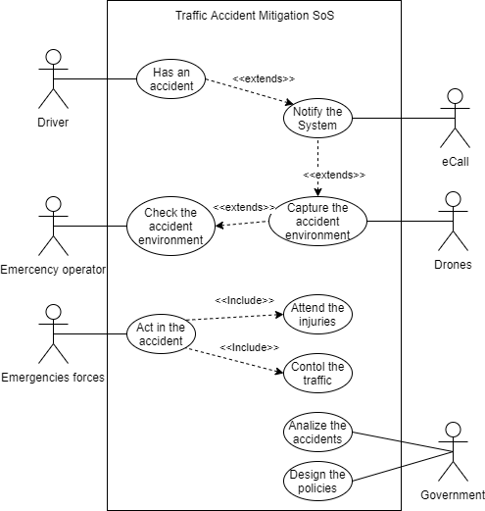

Figure 7:Traffic Accident Mitigation SoS

# Design

The aim of the design is to fulfill the goals and the requirement of the system-of-systems (SoS). This SoS involved existing independent systems that cooperate together towards the accomplishment of the main goal, previously described.

In this section, the systems chosen will be explained in details and their degree of integration and autonomy will be shown. In fact, the system characterization will be determined between these three types: directed, collaborative, acknowledged or virtual. Furthermore, the architecture of this design will be clarified. Some architecture patterns have been selected in order to simplify the global design of the SoS.

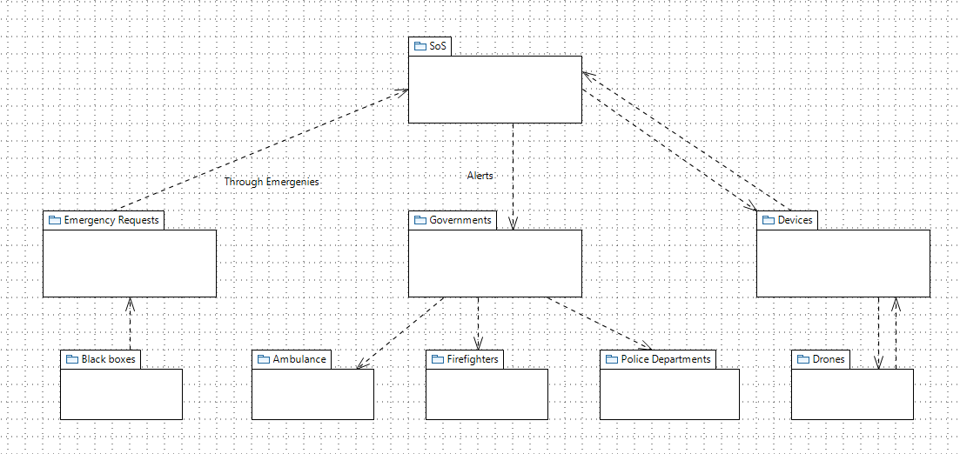

Figure 8: Papyrus design.

## 7.1 Systems chosen and compose the SoS solution

The system-of-system (SoS) is composed of independent systems. These systems work together to accomplish the common goals of the SoS. The hardware and software of the system constituents has been designed with autonomy, which means that in some cases there is needed a global integration between them.

Some quality attributes introduce by the requirements must be fulfilled with the design of the system. These attributes have been taken into consideration before drawing the general final design.

The first system included in our SoS solution is the e-Call architecture. This system calls to the e-Call node as soon as the accident occurs. The geo-located information is included in the call. In conclusion, this system gives us the emergency alert about an accident and the location of it. Besides, as all the vehicles must include this software, the e-Call node could know the number of vehicles involved.

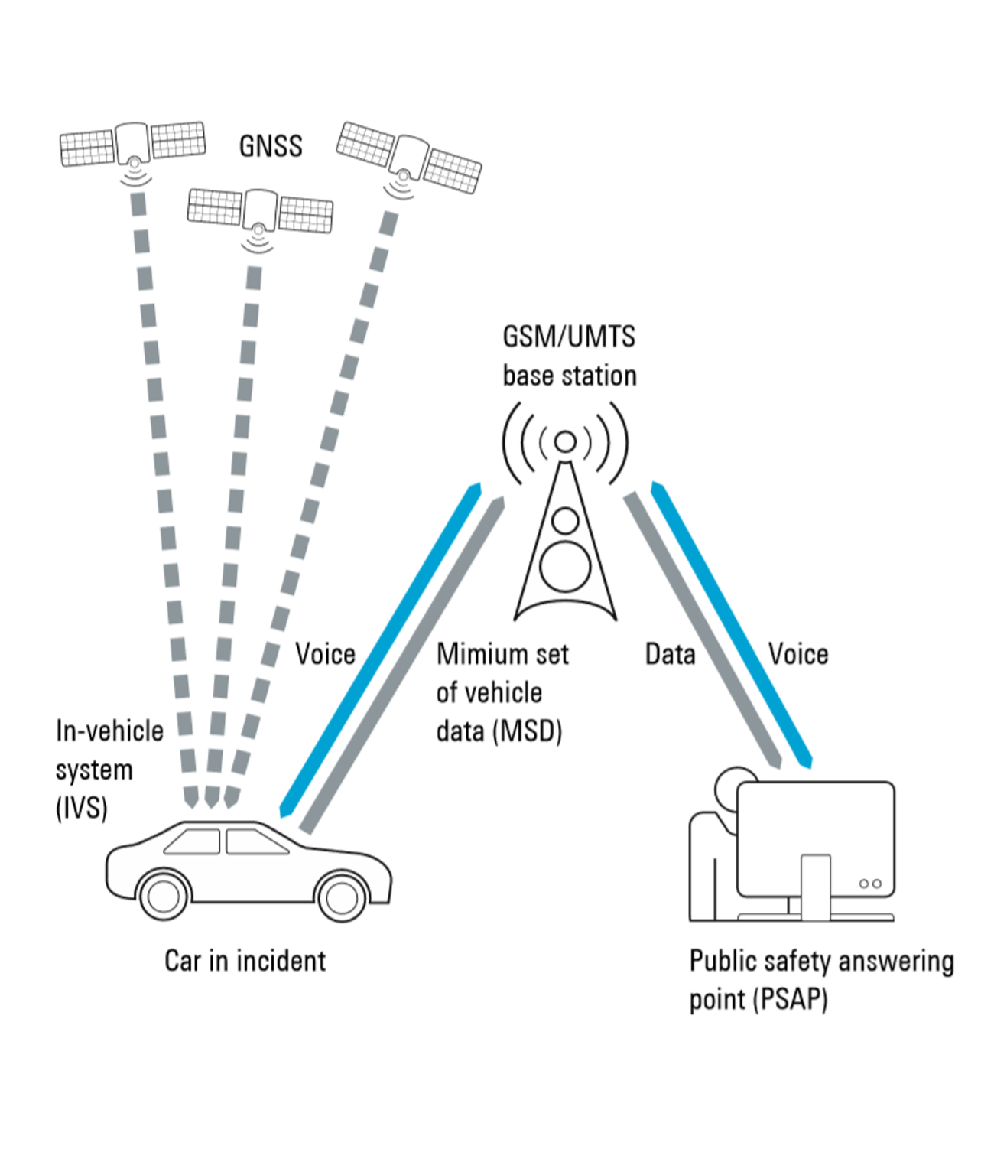

Figure 9: e-Call system.

The second system included in the SoS is the medical social system of the country. It involved hospitals, ambulances, and doctors among others. This system is controlled by the local authorities; hence the communication should be done with the local government. Once our system has decided on the number of ambulances needed, it will communicate this decision with the local authorities.

The police system is the third system included in our SoS. It involves all police units and vehicles. As with the medical system, the police system is under the control of the local authorities, which means the same premise: alert the local authorities with the decision made about the number of forces needed.

The firefighter system is also included in the global design of our SoS. It involves all firefighter units and vehicles. As the medical system and police system is firstly needed an alert to the local authorities.

All these four system constituents have a directed characterization with the global solution because are directly involved in the corrected performance of the solution. Without the cooperation of one of these systems, the SoS could not secure a complete solution for the user.

There are other systems that could be included in our SoS, but their relationship of cooperation is not directed. One example is the car insurance system, which has a collaborative relationship with our SoS. It is in charge of sending the car cranes to support the damage vehicles.

The local government could be explained as an independent system that has an acknowledge relation with our SoS. This system is informed about all the alerts and the decision made.

The whole SoS will be completed with some nodes that would be developed to implement the global design. Firstly, a central SoS node will be in charge of coordinate all alerts and information. It will receive the accident information from the e-Call system. This information will be stored in a local database. Secondly, some device nodes will be distributed amount of the city. They will contain N drones waiting for alarms. The number of drones of each device node will depend on the location of the node. Those of them that are near busy roads would need a higher number of drones to secure the service.

As soon as an accident alarm raise in the e-Call system, all the information would be sent to the SoS node. There would be evaluated which is the nearest device node with drones available and the order to the drone would be executed. All the information recorded by the drone will be sent to the device node, and it will send it to the SoS node.

Furthermore, the SoS node will be in charge of analyzing all the information available in an optimized machine learning algorithm. This artificial intelligence will take the decision about the complexity of the accident and how many emergency vehicles are needed in the supportive operation. Later, local authorities will be informed about the decision as soon as possible.

All the data is stored and shown in a user dashboard for the operators of the SoS node. These operators have the responsibility to secure that everything is working as expected and that the chosen decision is logical and smart enough.

## 7.2 Architecture patterns

Some reusable patterns have been used to make the problem easier. Two have been identified as suitable patterns for our specific issue.

In the Multi-Tier pattern [], all the structures are organized into logical groups. This groups could be allocated in specific physical components, such as the SoS node that is located in one building inside the city. In our SoS we have layers and tiers: the layers are the module structure and they should deal with time element, while in contrast, the tiers are components and connectors and they deal with runtime elements.

This pattern will promote the availability, maintainability, and modifiability of our SoS. These strengths are essential because of the importance of the solution. Errors in the final solution could produce fatal consequences that must be avoided.

In the publish-subscribe pattern [], publishers and consumers exist independently. All the data is related to one topic. All the publishers that want to send information have to define the topic of that information. Later, all the consumers subscribed to that specific topic will receive the information. This pattern is useful in our SoS because we need multiple and independent components accessing at the same information.

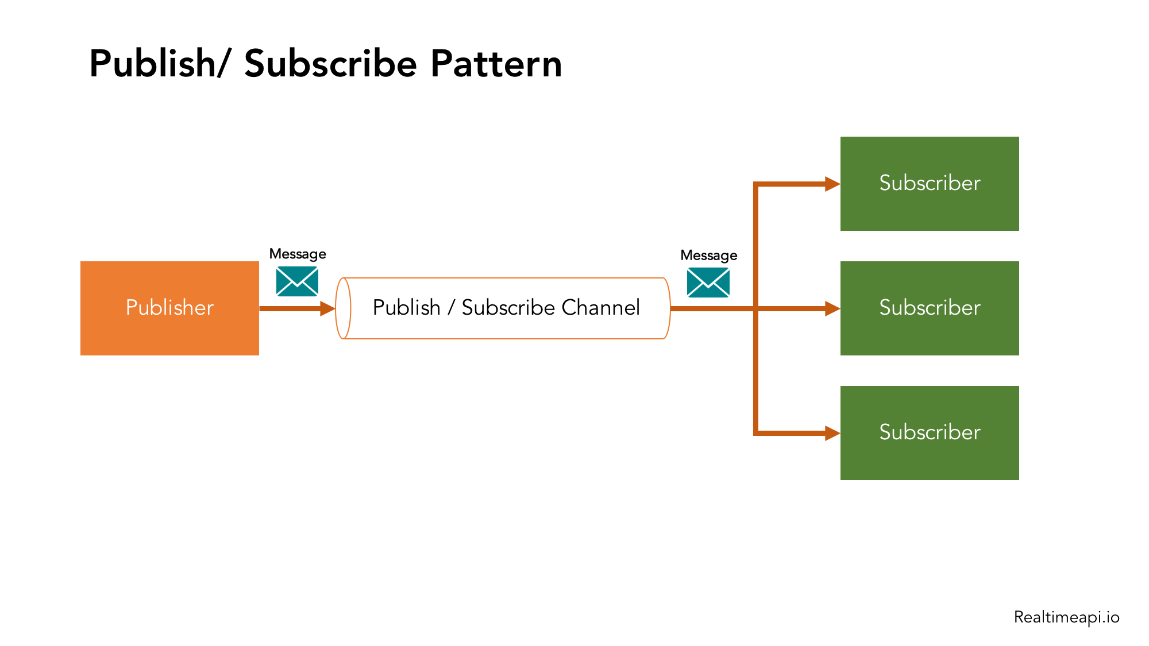

Figure 10: Publish/subscribe pattern.

All the alerts sent by the e-Call node will be aligned to a topic. This will facilitate the availability of the SoS if some of the nodes are down in certain moments. Also, between the drones and the SoS there will be a publisher-subscriber broker to secure reliable communication between all of them.

## 7.3 Architecture diagram

The following figure shows the architecture diagram of our SoS. All the nodes and the relations between them have been explained previously in detail.

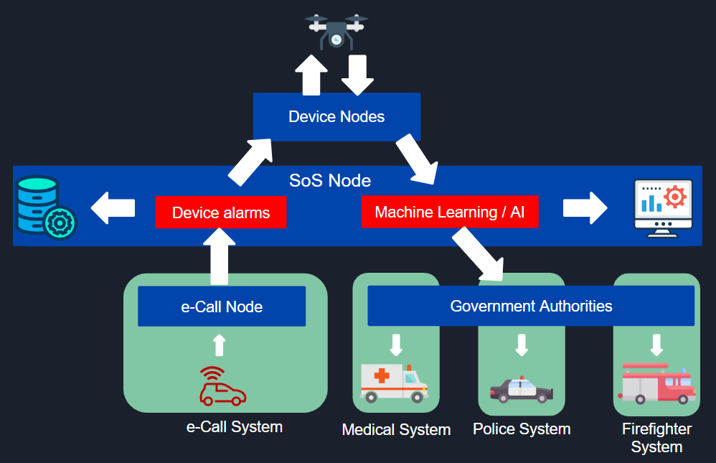

Figure 11: Architecture Diagram.

# Bibliography

|  |  |
| --- | --- |
| [1] | europapress, «europapress.es,» 30 11 2018. [En línea]. Available: https://www.europapress.es/madrid/noticia-112-recibe-ahora-45-millones-llamadas-ano-frente-millon-primer-ano-1998-20181130150457.html. [Último acceso: 25 12 2019]. |
| [2] | elconfidencial, «elconfidencial.com,» 28 08 2019. [En línea]. Available: https://www.elconfidencial.com/tecnologia/2019-08-28/drones-multas-dgt-radares-vacios_2193495/. [Último acceso: 22 12 2019]. |
| [3] | DGT, «dgt.es,» [En línea]. Available: http://www.dgt.es/es/sistemas-seguridad-vehiculos/nuevas-tecnologias/index.shtml. [Último acceso: 20 12 2019]. |
| [4] | dgt.es, «dgt.es,» 02 03 2017. [En línea]. Available: http://www.dgt.es/Galerias/seguridad-vial/investigacion/plan-investigacion/20170302-PLAN-INVESTIGACION-E-INNOVACION.pdf. [Último acceso: 22 12 2019]. |
| [5] | DGT, «Planificación de RRHH - DGT,» 01 01 2011. [En línea]. Available: http://www.dgt.es/galeias/la-dgt/empleo-publico/oposiciones/doc/2013/tema_41_parte_comun_mov_segura26e.doc. [Último acceso: 22 12 2019]. |
| [6] | P. d. Transparencia, «comunidad.madrid,» 09 2018. [En línea]. Available: https://www.comunidad.madrid/transparencia/compromiso/incorporacion-nuevas-tecnologias-emergencias. [Último acceso: 25 12 2019]. |
| [7] | C. G. Abajo, «tendencias21,» 10 02 2014. [En línea]. Available: https://www.tendencias21.net/Nuevo-sistema-para-coches-avisa-a-emergencias-si-se-produce-un-accidente_a30688.html. [Último acceso: 25 12 2019]. |
| [8] | W. H. Organization, «who.int,» 2015. [En línea]. Available: https://www.who.int/violence_injury_prevention/road_safety_status/2015/en/. [Último acceso: 22 12 2019]. |
| [9] | L.-B. Chen, K.-Y. Su, Y.-C. Mo, W.-J. Chang, W.-W. Hu, J.-J. Tang y C.-T. Yu,  «ieeexplore.ieee.org,» 17 12 2018. [En línea]. Available: https://ieeexplore.ieee.org/document/8576197. [Último acceso: 22 12 2019]. |
| [10] | Rohde-Schwarz, 11 2017. [En línea]. Available: <https://www.rohde-schwarz.com/es/aplicaciones/compruebe-sus-m-dulos-de-sistemas-ecall-y-era-glonass-ficha-de-aplicacion_56279-4097.html>. [Último acceso: 01 01 2020]. |
| [11] | RealTime API Hub, 2017. [En línea]. Available: <https://realtimeapi.io/hub/publishsubscribe-pattern/>. [Último acceso: 01 01 2020] |
| [12] | O`Reilly [En línea]. Available: <https://learning.oreilly.com/library/view/design-it/9781680502923/f_0062.xhtml>. [Último acceso: 30 12 2019] |
| [13] | O`Reilly [En línea]. Available: <https://learning.oreilly.com/library/view/design-it/9781680502923/f_0064.xhtml>. [Último acceso: 30 12 2019] |